Troy Ayon

CS 330 – Comp Graphic and Visualization

Final Project Submission Reflection

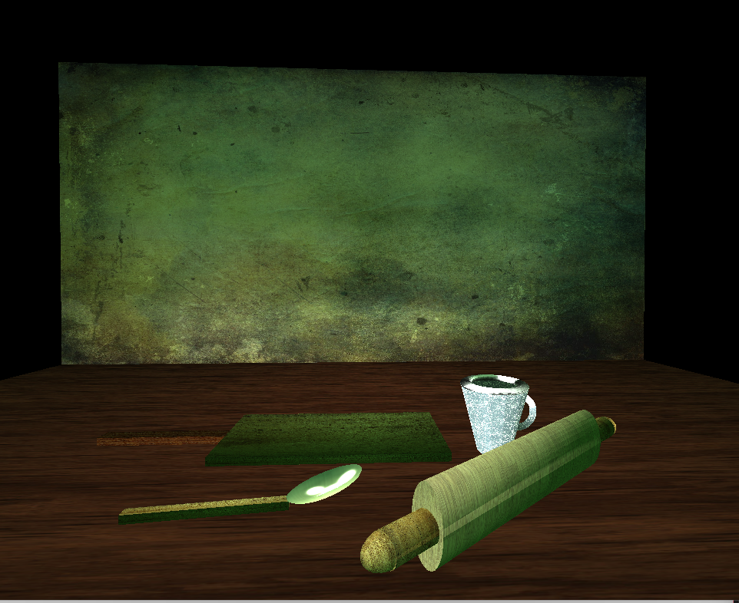

Above is a screenshot of the scene I created within Visual Studio that I submitted for my final project. When deciding what kind of scene I wanted to do, I decided to go for something that I see daily and as a cook and a baker, I decided to incorporate baking or cooking utensils within my final project. I included a serving or mixing spoon, cutting board with handle, coffee cup (as we all need caffeine especially when cooking) and a rolling pin. Originally instead of the coffee cup I had another spatula but while rendering it within my final project I noticed how flat the scene looked still and instead of just propping the spatula up on its side (which would be visually odd for a realistic 3D scene) I went ahead and replaced it with a coffee cup and a handle.

The design choices for all the objects I created did require additional shapes to add to them as each were complex. The most basic of the items was the cutting board which is essentially just two box meshes shaped differently and having different textures. The most complicated being the rolling pin which ended up having a cylinder for the main portion (roller) and then two cylinders that are for each end of the rolling pin as well as two half spheres that I used for the ends of the handles of the rolling pin. I set it at an angle as well to show dimension and depth to the 3D scene so that not all objects are just laying on the desk flat side by side.

As a user of the program approaches the scene, I did the required asks and programmed the keys to have the functionality of being able to go zoom in and out (forward and backwards) by using the “W” and “S” keys as well as look to the left and right of the scene using “A” and “D” keys. I also programmed accessibility for the user to use their mouse to look around the scene as well as lower the camera up or down using “Q” or “E” keys as well as the scroll wheel if necessary.

I used the shape meshes that were provided to us by our instructor but I added them to complex shapes and grouped them within my code so a user could easily take any of the desired shapes and use them by copying the code I made or by editing it to fit their needs. Each shape is separated within my code and tagged for easier readability. Also, the lighting and material shaders that I created do give off the amount of light reflection that I wanted based on the type of material so a user will be able to use those as well or adjust the shininess or abstract strength if necessary to make them even brighter.

Overall, the project itself was complex and challenging as someone without any real visual artistic skills could approach it and I feel that I was able to accomplish the asks in this project over the weeks and the functions and code that I created are easily readable and easy to manipulate to fit anyone’s needs.